**Group 16 - Mental Health Illness In Tech**

**Association Rule Mining and Clustering**

Chakravardhan Reddy - IMT2014015

Sandeep Tadepalli - IMT2014057

Abhijnu - IMT2014065

Keerthi Chandra - IMT2014064

Nithish - IMT2014016

**Clustering:**

**Target users:** Supervisors and higher officials in the company

The clustering is done based on the attributes tech_company, mental_health_consequence, co_workers. The two clusters indicates following things:

Cluster 1

Tech_company = yes

Mental_health_consequence = maybe

Co_workers = no

Cluster 2

Tech_company = yes

Mental_health_consequence = no

Co_workers = yes

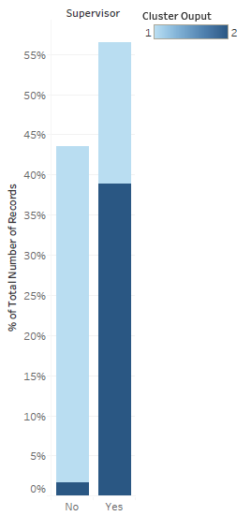

* After performing cluster characterization, we can see that cluster 2 people are most likely willing to talk to the supervisors than the people in the cluster 1.
* This will be useful to the supervisors and higher officials to get to know whether the employees are willing to talk to them or not.

**Association Rule mining:**

1)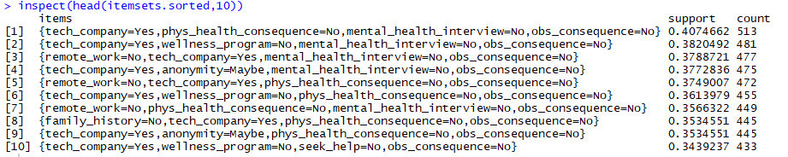

**Target users:** HR department in the companies

(tech company=Yes,obs_conseq=No,Mental_health_interview=No)

* From the above top 10 observations, we can infer an interesting itemset. If someone is working in tech company and he didn’t observe any negative consequences of co-workers facing mental health issues will most likely doesn’t bring his mental health issues in an interview.

2)

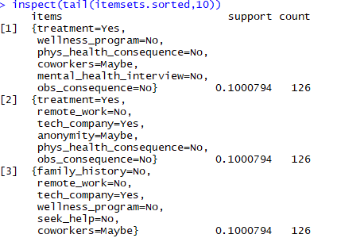

**Target User:** HR department in the companies

(Treatment=Yes,coworkers=Yes,Mental_health_interview=No are less)

* People who have sought treatment and may discuss with the coworkers but are not willing to discuss with the interviewer in the interview are very less.

3)

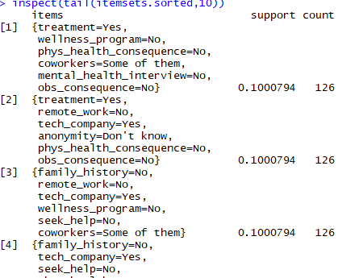

* Looking at the last 10, we see some rather large groups of answers that occur at least 10% of the time. Of this group, from those that sought treatment, they seem to also work in low-support environments. By low support, I mean information not provided about wellness programs, unknown or no anonymity, etc. It seems that a belief that there would not be negative consequences for mention of a physical ailment is common.

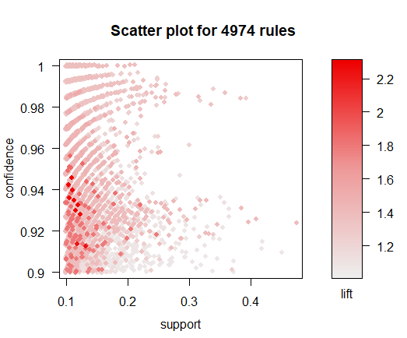

* Looking at the plot, it seems that the responses which are most dependent for these confidence and support parameters are at ~0.1 support and 0.92 to 0.94 confidence.

1)

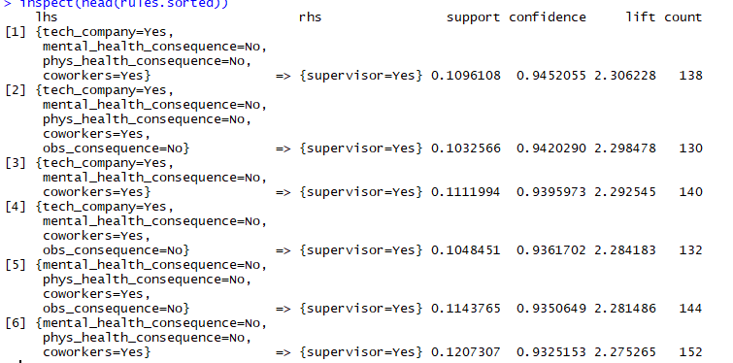

**Target User:** Supervisor and Higher officials

(tech_company=yes, co workers = Yes, phy_consequence = No, mental_consequence = no)

* All of the top rules (by lift) concern whether or not an employee would surely discuss their mental health with their supervisor(s). There are people who would also discuss with their coworkers, who don’t believe there would be negative consequences for doing so (similarly with physical conditions), and often have not observed negative consequences for doing so. These conditions, especially in the first two rules occur about 10% of the time, but over 94% of the time those conditions come together.

2)

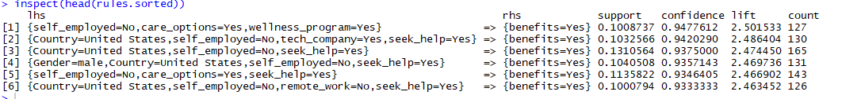

**Target User:** Employees

(Country = USA, Self Employed = No,Care_options = Yes, Seek_help= Yes)

* All of the top rules (by lift) concern whether or not an employer would provide mental health benefits to their employees. These people are mostly from united states , they are not self employed, they know about the care options provided by their employer. These conditions occur about 10% of the time, but over 94% of the time those conditions come together.

3)

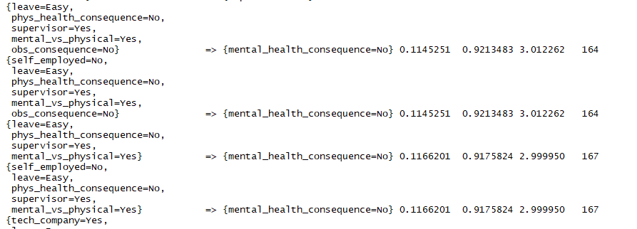

**Target User:** HR department in the companies

(Leave= Easy,Phy_conseq= No,Supervision= Yes)

* From the above observations, primary concern is whether discussing the mental health would have negative consequences or not. These people think that they get leave easily, they think discussing physical health will have no negative consequences, they are willing to discuss with the supervisor. These conditions occur about 10% of the time, but over 92% of the time those conditions come together.

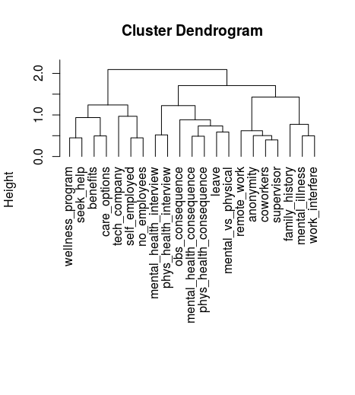

* This is performed to cluster variables capturing similar attributes in data.
* This graphical clustering helps in the suitable number of clusters.

We can see similarity between some of the attributes like

1)physical_health_consequence and mental_health_consequence

2)Wellness_program and seek_help and benefits and care_options

3)Mental_health_interview and physical_health_itnerview

4)Coworkers and Supervisor and Anonymity